**CITI-BRIDGE PROGRAM**

**Clearing Feed Generation**

1. **Introduction**

The purposeof the Clearing Feed Generation system is to automate the activities of the valid and invalid transaction. Some of the key benefitsof the system include the increase in the efficiency, giving an easy remote access to stakeholders. Generate the feed file towards clearing system in a specific format based on the input transactions to the system.

**Overall Description**

**Product Perspective**

Clearing Feed Generation System is the part of banking companies to process the valid the authorized author of the account.

**Operating Environment**

The clearing feed generation system will be windows based supporting versions windows. The minimum configuration required on server platform is 2.4 GHZ, 80 GB HDD for installation, 512 MB memory. Users can use any PC based browser clients with IE 7.0 upwards. For smartcard based authentication existing smart card software is assumed. Standard Graphics library supported in IDE will be used.

**Functional Requirements:**

1. Transaction Management System
2. Maintain a state model for transaction traversing workflow: upload -->Valid-pass or Validation-fail -->Feed-Generated.
3. Cater to exception handling along the workflow.
4. Input file Upload
5. Poll a local folder to pick up input transaction file.
6. Perform validation on the file format, i.e. file naming convention, record length, number of fields within records, field length, date format, currency format.
7. Once the file is read, move the file to another folder to archive it.
8. Clearing feed Generation
9. Provide a UI screen to show all the Transaction that have been validated successfully.
10. Provide a function to generate a clearing feed file having transaction Valid and Invalid.

**Performance Requirements**

Simultaneous access to the system is expected.

Time for process less than 60 sec.

**Class Diagram**

**DEMONSTRATION**

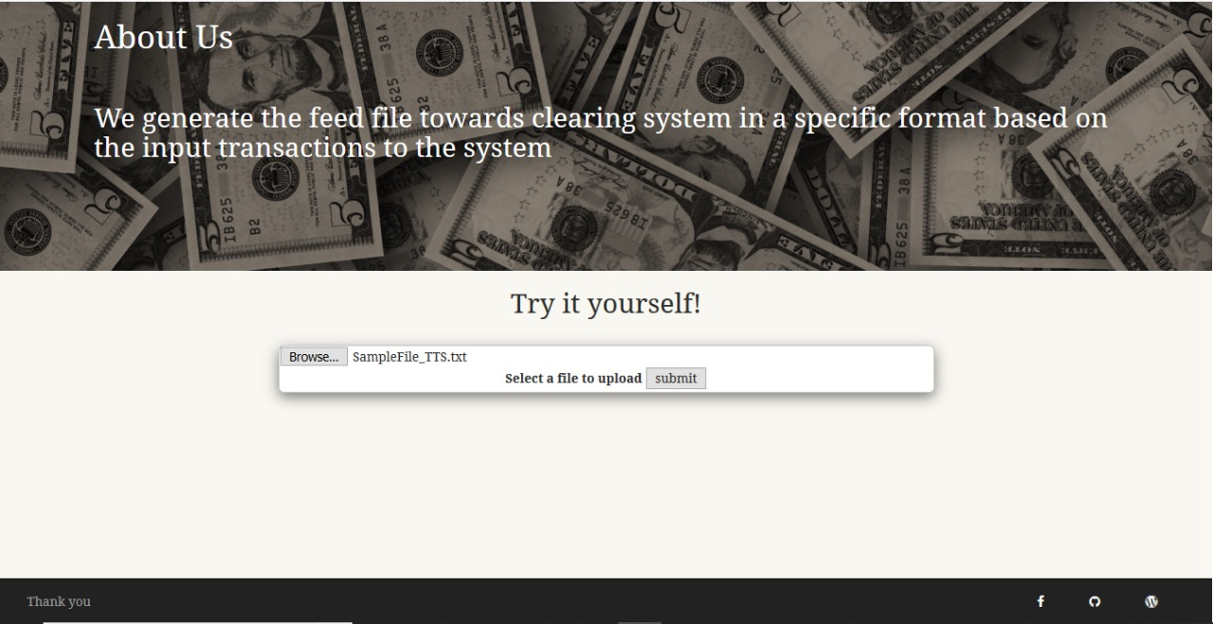

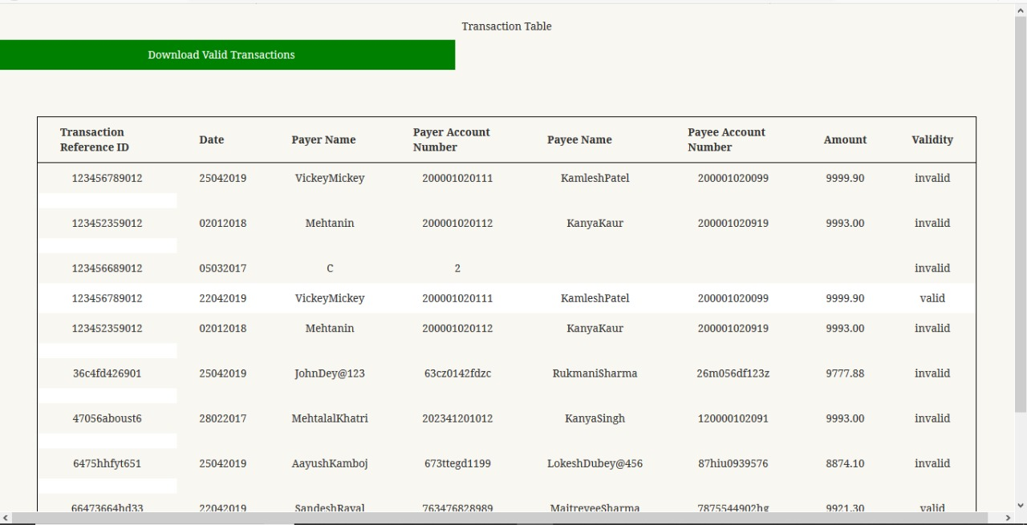

**Future Scope**

The overall transactions of a day can be uploaded on the cloud and shown on a graph with the successful and failed rate of transactions.

If any transaction fails for multiple times then that ID can be added to the blacklist for the next 24 hours.

All the transaction can be stored using database and can be analysed on the weekly or monthly basis.

**Conclusion**

If your submitted data for the transactions is as per the norms of both the involved clients, only then will your transaction be considered successful.

Clearing feed acts as the mediator in validating transactions.

After clearing feed, the valid-feed.txt file is generated which will be given as input to the sanctioning process.